# MSP-EXP430FR6989LP

MSP-EXP430FR6989LP , a launchpad kit developed by Texas Instruments containing 40 pins among which include GPIO pins, UART pins and also ANALOG pins. The launchpad also contains on-board buttons and LED’s for quick integration of simple user interface and a LCD display.it has 128kb of FRAM,12-bit ADC.

A simple experiment is conducted using LED to get familiarized with the GPIO pins on the launchpad kit. Using the function [pinMode()] the pin number is selected as OUTPUT and the LED is set as HIGH or LOW using function [digitalWrite()] and a delay. A simple code for the blinking of the LED is achieved and executed on the kit and connecting external LED’s, also the on-board LED’s can also be used by selecting appropriate pin number. A similar experiment using three LED’s is carried out for the TRAFFIC LIGHT SIMULATION, for which code is written so that the LED’s blink in order as of the traffic signals. Similarly the on-board switch S1 is used to switch on and off LED, the function used is [INPUT_PULLUP()] the appropriate pin for the switch S1 is selected and the LED is controlled. For this experiments Buzzer can also be used.

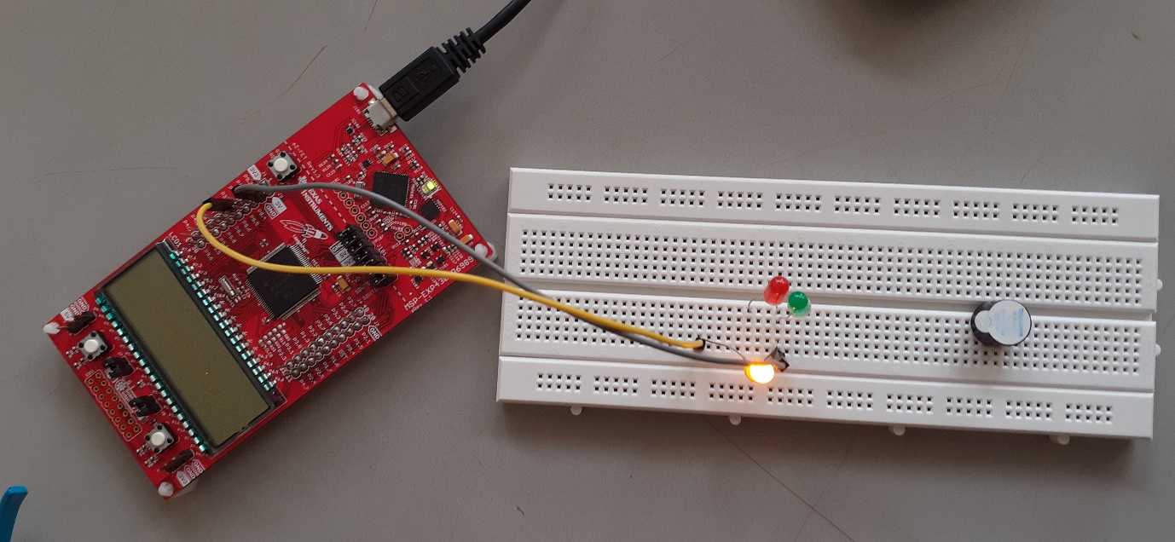

The ANALOG pins on the launchpad are used to read and write analog values to the external devices such as LED’s ,sensors ,buzzers etc. The 10 bit ADC is responsible for all the conversions of the values on the analog pins.

The analog functions used are [**analogRead()**] :Reads the value from the specified analog pin. The LaunchPad board typically contains 8 channel, 10-bit analog to digital converter. Check your LaunchPad for specific channel and resolution information. This means that it will map input voltages between 0 and ~3.3 volts (VCC) into integer values between 0 and 4095.

[**analogWrite()**]:Writes an analog value (PWM wave) to a pin selecting the appropriate PWM pins on the kit. Can be used to light a LED at varying brightness or drive a motor at various speeds. After a call to **analogWrite()**, the pin will generate a steady square wave of the specified duty cycle until the next call to **analogWrite()** (or a call to **digitalRead()** or **digitalWrite()** on the same pin).

For the communication function of the kit the [**Serial**] function is used ,some of the functions are Serial.begin(), Serial.println(), Serial.available(), Serial.read(), Serial.write(), etc.All the communicating functions are used using UART pins n the board.

Serial.begin() function is used set the baud rate as the communicating frequency, for example [ void setup() { Serial.begin(9600); } ], here the baud rate is 9600Hz. Similarly the Serial.println() function is to print values and the values are observed on the Serial Monitor Window of the ENERGIA software.

Serial.available()function gets the number of bytes (characters) available for reading from the serial port. This is data that's already arrived and stored in the serial receive buffer. Serial.read()function reads incoming serial data. Serial.write(),Writes binary data to the serial port. This data is sent as a byte or series of bytes; to send the characters representing the digits of a number use the print() function instead.

The examples for above Serial functions is: read the data available and print,

int incomingByte = 0; // for incoming serial data

void setup() {

Serial.begin(9600); // opens serial port, sets data rate to 9600 bps

}

void loop() {

// send data only when you receive data:

if (Serial.available() > 0) {

// read the incoming byte:

incomingByte = Serial.read();

// say what you got:

Serial.print("I received: ");

Serial.println(incomingByte, DEC);

}

}

The UART transmitted values are observed on the CRO as waveforms as shown, her the value is :5 and function used is Serial.write(value);